Temple of the Dragonknights

A Simple Adventure Module

Introduction: Venomfang, a young green dragon, has recently perched herself in the burial ground of an ancient group of dragon slayers
known as “The Dragonknights.” As she hunts in the nearby forest, her kobold minions gather to raid the nearby town of Fallcrest to bring
riches to themselves and their master, but it seems Venomfang and her minions may have a darker, more sinister purpose…

A four-hour adventure for two 1st-2nd level characters

by DAWSON WOOD



DUNGEONS & DRAGONS, D&D, Wizards of the Coast, Forgotten Realms, the dragon ampersand, Player’s Handbook, Monster Manual, Dungeon Master’s Guide, D&D Adventurers League, all other Wizards of the Coast product names, and their respective logos are trademarks of Wizards of the Coast in the USA and other countries. All characters and their distinctive likenesses are property of Wizards of the Coast. This material is protected under the copyright laws of the United States of America. Any reproduction or unauthorized use of the material or artwork contained herein is prohibited without the eXPress written permission of Wizards of the Coast.

©2016 Wizards of the Coast LLC, PO Box 707, Renton, WA 98057-0707, USA. Manufactured by Hasbro SA, Rue Emile-Boéchat 31, 2800 Delémont, CH. Represented by Hasbro Europe, 4 The Square, Stockley Park, Uxbridge, Middlesex, UB11 1ET, UK.

Part I: Innocents Lost
In this part of the adventure, the players will encounter their first kobolds, investigate a small farmstead, and locate the source of the attacks…

A. Northcrest
The town of Northcrest contains multiple key locations such as The Flowing Mug Inn, a blacksmith, and a market square.

The Flowing Mug Inn

The adventurers begin in The Flowing Mug. How they got there and how they met is up to the players and the DM. The Flowing Mug is your typical tavern as well as Inn. It is known by the local townsfolk as a trustworthy, “stand-up” Inn.

Additional Information
- Richard Brown: Male, Human, mid-sixties, barkeep
- Lauraine Brown: Female, Human, early-sixties, innkeep
Item Cost
Mug of Ale  Room (Per day) | 4 cp
Mug of Ale  Room (Per day) | 5 sp
Meals (per day)  Common Wine | 3 sp
Meals (per day)  Common Wine | 2 sp

When it seems appropriate, perhaps after ordering a few drinks and introducing themselves, the players
here the sounds of yelling & grunting outside. – SEE “KOBOLDS VS GUARDS”

The Blacksmith

The blacksmith shop is a good place to have the adventurers go if they need to resupply on weapons, armor, or ammunintion.

Additional Information
Anything the blacksmith doesn’t have on hand can be requested to create for 1.5x its value in The Player’s Handbook.
- Dorn Stoutheart: Male, Human, late-thirties, blacksmith
- James Turin: Male, Human, late-teens, blacksmith’s apprentice
Item Cost
Arrows (20) | 1 gp
Hide Armor  Chain Shirt  Ring Mail Shield | 10 gp
Hide Armor  Chain Shirt  Ring Mail Shield | 50 gp
Hide Armor  Chain Shirt  Ring Mail Shield | 30 gp
Hide Armor  Chain Shirt  Ring Mail Shield | 10 gp

Market Square

The market square contains multiple small, specialized stalls.

Additional Information
- Valerie Renn: Female, Human, mid-twenties, produce
- John Goodard: Male, Human, late-twenties, freshly hunted meats
- Abraham Calhoun: Male, Human, mid-fifties, freshly caught fish
- Venona Glowsky: Female, Half-Elven, early-twenties, freshly hunted pelts
- Talia Pinsinger: Female, Human, late-forties, jeweler ...and others.

Later on in the adventure, the adventurers may recover stolen supplies from the kobolds. They would return these barrels to the market square.

B. Kobolds vs. Guards
After hearing noises from outside The Flowing Mug Inn, the adventurers investigate outside to find 4 guards rushing to action against 6 invading kobolds, who appear to have green skin. Resolving this encounter yields 100 XP divided amongst the party.

Saving Joel Andersmith

Joel Andersmith, a farmer from North of town, will be found lying against the wall of The Flowing Mug after the fight. If asked, he will provide the following information

Additional Information
- The kobolds have raided his farm and murdered his family.
- He believes that the kobolds may be more kobolds in the forest to the North
After this information is given, Joel will burst into tears over the loss of his family. The town guards will escort him to the Inn and pay for his stay as long as he needs. The guards will also insist that they must stay in town to protect it from potentially worse threats.

Capturing a Kobold

If the players manage to capture and interrogate a Kobold, a DC 15 Persuasion or DC 12 Intimidation check will conclude with the captured enemy revealing information.

Additional Information
- The location of Poisontip Cavern: North past the farmstead and through the brush.
- The location of Fallcrest’s missing supplies: Poisontip
Cavern
- The fate of Joel’s family: His wife and son are dead, but they needed his daughter.
- Information regarding Venomfang and her intentions will not be revealed.

C. Andersmith Farm
About a mile North of town, bordering the forest, lies what’s left of Andersmith Farm. Smoke rises all along the crops and slaughtered animals lie scattered across the ground. A house overlooks the farmland on a small hill to the East, and a barn lies in semi-ruin to the North, bordering the forest.

The Barn

Upon closer inspection of the barn, the entire Eastern half is caved in, with piles of broken wood lying scattered across the ground. Blood tracks lead outside the barn but eventually fade. A DC 7 Survival check will reveal the tracks’ destination; the brush behind the barn. There are also the remnants of ransacked barrels and supplies.

The Farmhouse

Walking in the front door of the farmhouse (which hangs off of one of its hinges) reveals the interior; a main room previously used as a living room & dining room, and two hallways that branch to the left and right.

The Left Hall
Down the left hall there is a bedroom on each side. The bedroom on the left is Joel’s son’s room. He lies on the ground with his gut split open, and a simple shortsword at his side.
Across the hall is Joel’s daughter’s room, which is empty save for the ruined furniture and a bloodstained teddy bear lying in the bed.

The Right Hall
Down the right hall there is a washroom to the left and another bedroom. In the bedroom, a middleaged woman lies leaning against a large bed with a slit throat.

A DC 10 Survival check will reveal tracks that lead to the back side of the barn,

D. The Trail
The players will eventually follow tracks that reveal an unnatural looking thicket. This can be cut through or, with a DC 11 Investigation check, a vine connecting to a mechanism can be found that pulls the brush up. The following trail is 5 ft. wide and must be traveled single-file.
A passive perception of 12 will find a small lock of hair along the trail. An intelligence check DC 15 will discern that it’s human.

The Creek

Following the trail through the woods for a mile leads to an opening to a small creek. Small, slippery stones create a path across the creek. Crossing safely takes a successful DC 12 Acrobatics or Athletics check. A failure results in falling into the creek, where two quippers sense fresh meat. Crossing the creek awards 20 XP to each character. After crossing the creek spears topped with human skulls begin to dot the trail.

Cave Entrance

After a curve in the trail, a DC 12 Passive perception check will signify movement around the corner. Turning the corner reveals two kobolds currently roasting a pig on a spit. They are currently eating so any attempt at stealth is successful. This encounter yields 50 XP divided amongst the party.

Part II: Poisontip Cavern
In this part of the adventure, the players will eXPlore and fight their way through Poisontip Cavern. The cavern is extremely dark and those who don’t have darkvision will be completely blind. The 2nd floor is 15 ft. above the 1st…

Area 1
This section of the cavern is relatively straightforward. The players will immediately be attacked by a single winged kobold upon entering. This encounter yields 50 XP divided amongst the party.
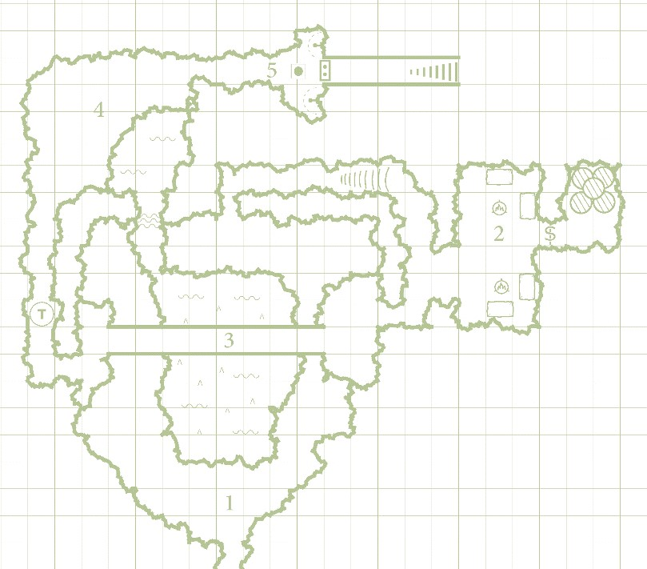
This area involves crossing a rickety bridge over a lake full of stalagmites, and a trap.
Puzzle Clue

The parchment reads in Common: “Legends
are
born through blood and fire,
”

and contains the
emblem of the
Dragonknight
s.

On the back it reads
in scribbled Draconic: “
We brought the girl to the
robed ones. Not sure why they wanted her, but
whatever it takes to please the master.”

Additional

Information

•

The emblem of the
Dragonknight
s appears as a snake
-
like
cre
ature wrapped around a sword.

Area 3

Crossing the Bridge
After this encounter, the players may notice the cliff drop below them, into a small underground lake. Depending on their ability to see, they may stumble into it. See AREA 3 for details. A small passage on the right of the lake requires a DC 8 Acrobatics check to cross.

Area 2
After finding the passage way and taking the stairs up to area 2, The players encounter 3 kobolds sleeping in corresponding tents (unless the winged encounter was very very loud). This encounter yields 75 XP. The following items are found in tents.
Additional Information
- In the Northernmost tent is 25 gp and a piece of parchment that appears to be torn out of a book. See PUZZLE CLUE
- In the tent to the Southeast there are two Potions of Healing.
- The secret door on the Eastern wall takes a DC 10
Perception check to notice, and a DC 14 Athletics check to budge open.
- Inside the secret door are all the town’s missing supplies, which the players may inform the townspeople of, or return them themselves (100 gp & 20 XP each if they do it themselves).

The skill used to cross safely is Acrobatics. The base DC is 0 for 80 lbs or lower at one time. The DC increases the more weight there is.
Weight (lbs) DC
x < 80  80 < x < 130  130 < x < 180  180 < x < 230 x > 230 | 0
x < 80  80 < x < 130  130 < x < 180  180 < x < 230 x > 230 | 5
x < 80  80 < x < 130  130 < x < 180  180 < x < 230 x > 230 | 10
x < 80  80 < x < 130  130 < x < 180  180 < x < 230 x > 230 | 15  20
If any player falls in, roll a percentage. If the percentage is under 15% the player takes 1d6 piercing damage from a stalagmite, otherwise they take no damage. There are 4 hungry quippers waiting in the water below the bridge. Crossing the bridge yields 75 XP divided amongst the party.

Triggering the Trap

Following the bridge, immediately after is a pressure triggered trap that is triggered by anyone over 120 lbs. If triggered, anyone in that 5x5 ft. square is pelted with rocks, suffering 1d6 bludgeoning damage. Disarming the trap yields 10 XP to the one who disarmed it.

Area 4
Area 4 contains a single piercer hanging above a single chest. The ceiling is 20 ft. high. Within the chest is 25 gp. As soon as someone opens the chest, the piercer will drop on its target. Completing this encounter yields 100 XP divided amongst the party.

Area 5
This area contains an offering bowl, a large stone double door, and two lit torches in sconces on each side of the door. The door has the Dragonknight emblem on it, and the offering bowl is full of gold (20 gp)
Additional Information
- To solve the puzzle, the players must poor a portion of their blood into the offering bowl, and light the blood on fire using one of the magical torches on the wall.
- Emptying the bowl of gold and making a DC 10
Investigation check will reveal dried blood on either the gold or on the bowl.
Opening the door yields 50 XP divided amongst the party and reveals a pathway and staircase going up.

Part III: Temple of the Dragonknights
In this chapter, the party will rescue a potential ally, determine the fate of Joel’s daughter, and potentially face off with a dragon…

Area 1
This area contains four coffins of four long dead Dragonknights. If the players step on the emblem on the center of the floor, four zombies (nerfed to 11 hp and 1d4 dmg) will burst out of their tombs. This encounter yields 100 XP divided amongst the party.

Additional Information
At this point, the party should be level 2. At this point it is recommended that you do not continue until you level your characters. The DM should determine when a good stopping point is based on your party and their situation.

Area 2
This room is drapped in torn and burnt banners of the Dragonknights, but within the circular outskirts of this room lie an armory. In the armory, a kobold cultist (cultist stats) is torturing a young Elf wizard named Sera Gelanadel. This encounter yields 25 XP divided amongst the party.

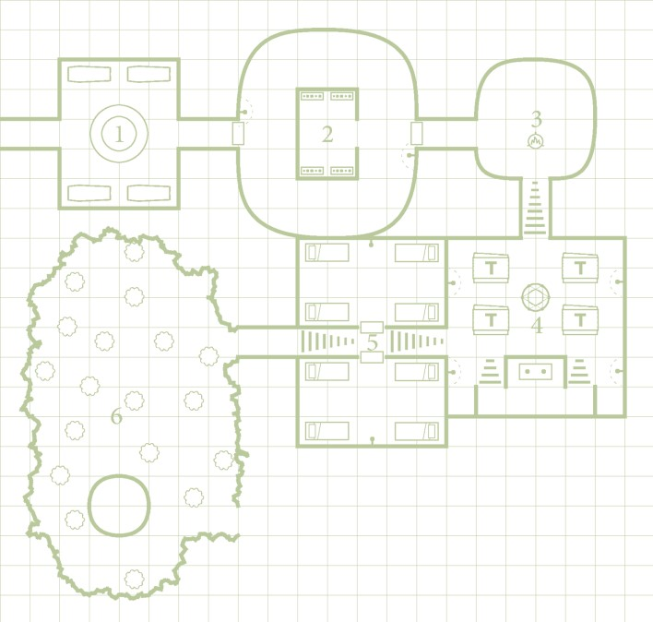
Additional Information
- Sera is a famous wizard’s apprentice and was sent to investigate the strange arcane energy originating here, how she is played and any additional backstory are up to the DM, or perhaps a third player. She is a level 1 Wizard
- A DC 10 Investigation check of the weapon racks reveals a Spear of the Dragonknights (+1 spear). The DM may change the weapon type to fit one of the players if he/she wishes.
- Sera has 2 Potions of Healing on her.

Area 3
This room contains a single brazier, and a massive stone carved frieze depicting an epic tale of dragonslaying. A DC 18 Investigation check will reveal a hidden groove in the stone that contains a single platinum ring (250 gp) inside.
After looking over the beautiful artwork on the wall, have a character notice a fourth shadow. This shadow will initiate combat. This encounter yields 100 XP divided amongst the party.

Area 4
In this room, there are 4 tables with benches, a ritualistic rune in the ground, and a podium in the southernmost portion of the room. The players walk into 5 cultists in the middle of performing a ritual on Joel’s daughter. She is currently hanging suspended by magic beaming from the cultists’ hands. This encounter yields 125 XP divided amongst the party.

Additional Information
- Joel’s daughter can be roleplayed as the DM sees fit, but after the ritual is interrupted, she falls unconscious. Her name is Clementine Andersmith
- A DC 12 Investigation check will reveal 2 Potions of Healing in a hidden compartment in the podium.
- A book on top of the podium lies open. A DC 15 Arcana check will discern the ritual’s nature.
- A DC 14 History check will inform the player that soul gems are used to turn creatures into liches.

The Ritual

Venomfang’s goal with this ritual is up to the DM. In my game Venomfang wants to revive a Dracolich, so her goal here was to create one of the gemstones required to store the Dracoliches soul, but again, this ritual’s purpose is up to the DM.

Area 5
Nothing terribly significant here. Two sleeping chambers for previous members of the Dragonknights now being occupied by the cultists. A DC 10 Investigation check will reveal a Potion of Healing in a nightstand in the Northernmost room.

Area 6
Upon exiting up the stairs to this open area, the players find themselves in a clearing atop a mountain with a surprisingly peaceful forest. During this time, a green dragon wyrmling will be stalking the party.

Additional Information
- The green dragon wyrmling will attempt to stealth and stalk the party until they reach the marble platform in the southern portion of the area.
- On the marble platform, there is a toppled statue of the dragonknights, and 4 dragon eggs.
- As one of the players notice one is opened, the wyrmling will attack (unless the players noticed it previously.) • Clementine will hide in area 5.
This encounter yields 450 XP divided amongst the party.

Part IV: Loose Ends
The party has saved Joel’s daughter, faught a dragon and her minions, and potentially saved the town of Fallcrest. What’s next?

A. Returning Home
On the opposite side of the entrance, is an exit with a path down the mountain. To any party members who were paying attention, it shouldn’t be hard for them to find their way back. The exit is on the Southern side of the mountain near the entrance to Poisontip Cavern.

B. Hope Restored
Joel can be found upstairs in The Flowing Mug Inn, reading a book in his room. Returning Clementine to him lights a fire in his heart that can only be described as renewed hope for his life.

C. Supplies Returned
Returning the supplies to the market garners some benefits (100 gp & 20 XP each and the townsfolks approval.)

D. Venomfang
Venomfang returns to her lair to find it in ruin, and one of her children is missing. This allows for the DM to do whatever he/she wants with this villain, who certainly wants revenge.

E. Sera and the Temple
Sera returns to her home city of Waterdeep to report to Archmage Vysellon on the strange goings-on in the Dragonknight Temple.

